**Explore Azure database and analytics services**

After completing this module, you'll be able to describe the benefits and usage of:

* Azure Cosmos DB
* Azure SQL Database
* Azure SQL Managed Instance
* Azure Database for MySQL
* Azure Database for PostgreSQL
* Azure Synapse Analytics
* Azure HDInsight
* Azure Databricks
* Azure Data Lake Analytics

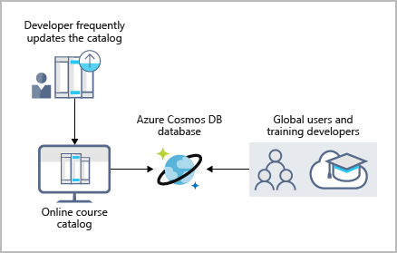

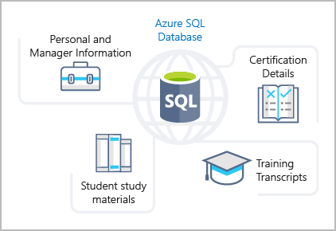

Creating SQL Database

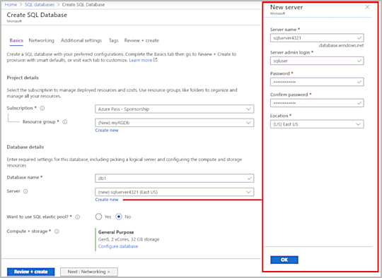

* 1. Select **OK** when you have finished.

1. Select the **Next: Networking>** at the bottom, and configure the following settings (leave others with their defaults).

| **TABLE 3** | |
| --- | --- |
| **Setting** | **Value** |
| Connectivity method | **Public endpoint** (default) |

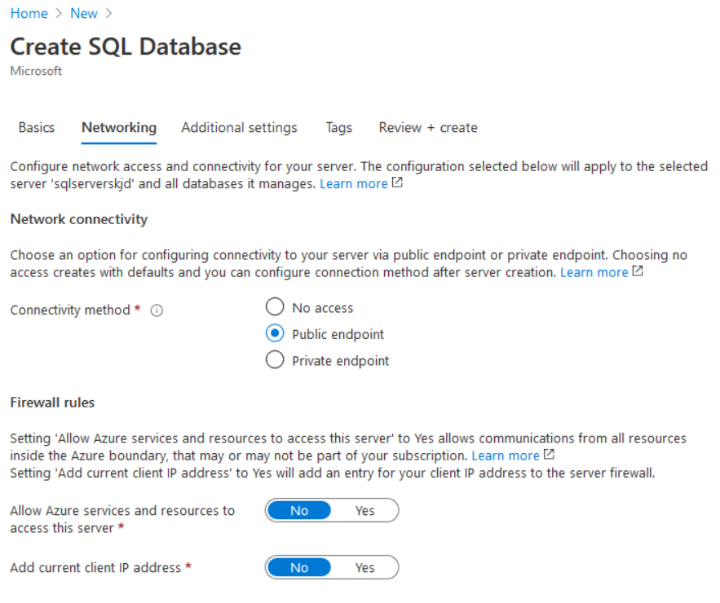

Select the **Additional settings** at the top, and configure the following settings.

| **TABLE 4** | |
| --- | --- |
| **Setting** | **Value** |
| Data source | **Sample** (this will create the *AdventureWorksLT* sample database) |
| Collation | ***use default*** |

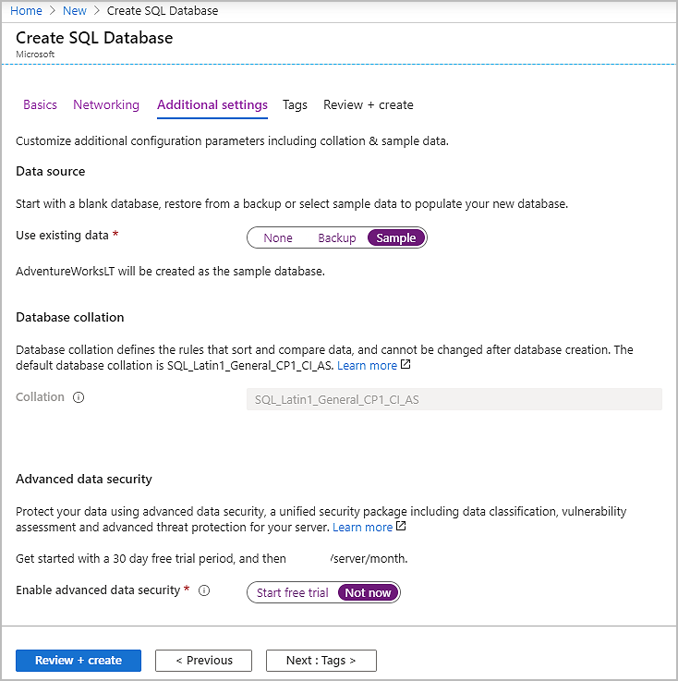

1. Select **Review + create** > **Create** to deploy the server and database.

It can take approximately 2 to 5 minutes to create the server and deploy the sample database.

1. Select **Go to resource**.
2. Select **Set server firewall** and Allow Azure services and resouces to access this server = **Yes**.
3. Select **Save**.
4. Select **OK**.

## Task 2: Test the database

In this task, you configure the server and run a SQL query.

1. From the **All resources** pane, search and select **SQL databases** and ensure that your new database was created. You might need to refresh the page.

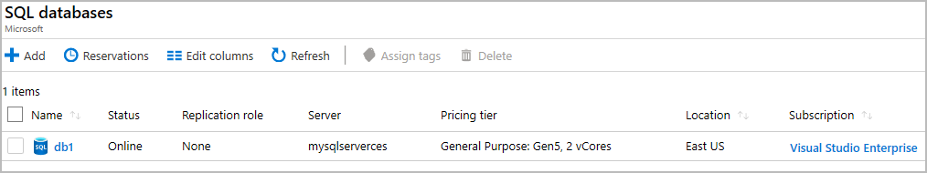

1. Select the **db1** entry representing the SQL database you created, and then select **Query editor (preview)** on the left side.
2. Sign in as **sqluser**, with the password **Pa$$w0rd1234**.
3. You will not be able to sign in. Read the error closely and make note of the IP address that needs to be allowed through the firewall.

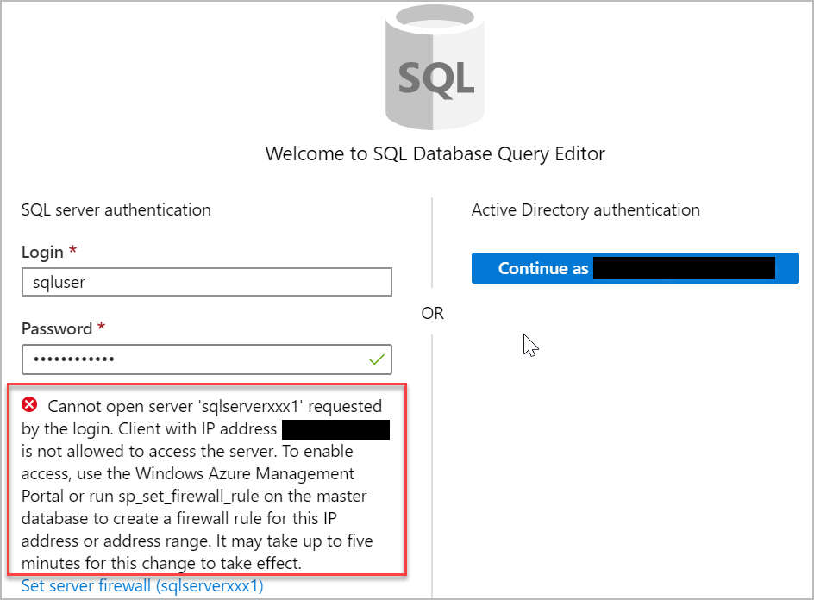

1. Select **Overview** > **Set server firewall**.
2. In **Client IP address** your IP will be shown, create a **Rule name** > Add your IP in both **Start IP and End IP** and then select **Save**.

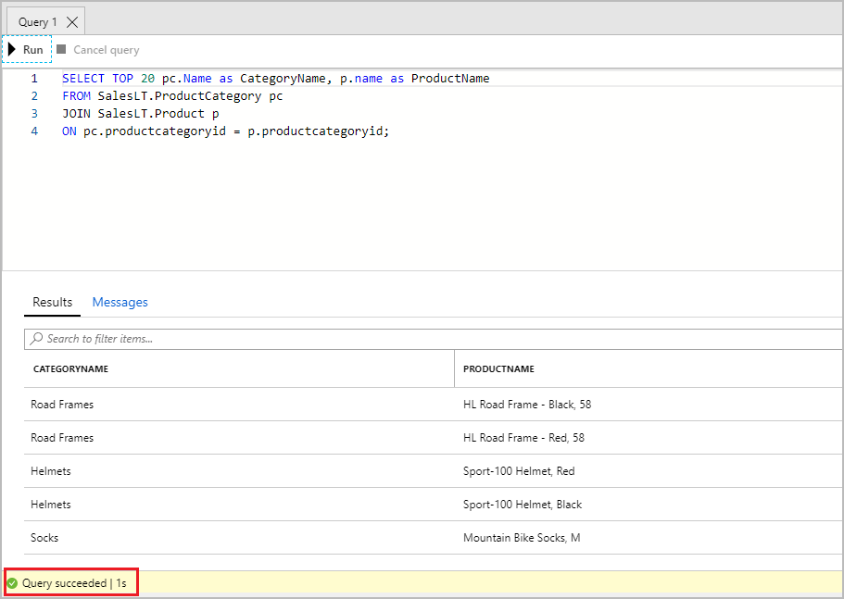

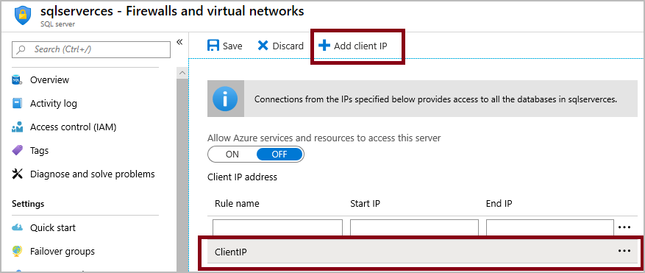

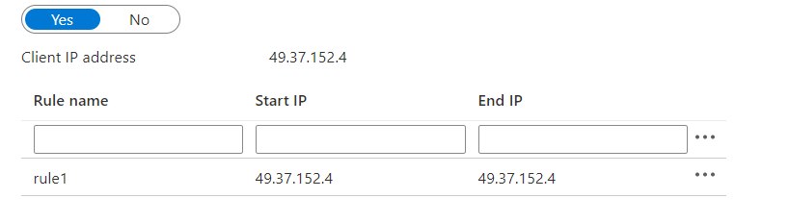

1. Return to your SQL database and the Query Editor sign-in page. Try to sign in again as **sqluser**, with the password **Pa$$w0rd1234**. This time you should succeed. It might take a couple of minutes for the new firewall rule to be deployed. If you wait and still get an error, try selecting **Firewall settings >** again.
2. After you sign in successfully, the query pane appears. Enter the following query into the editor pane.

SQLCopy

SELECT TOP 20 pc.Name as CategoryName, p.name as ProductName

FROM SalesLT.ProductCategory pc

JOIN SalesLT.Product p

ON pc.productcategoryid = p.productcategoryid;

Select **Run**, and then review the query results in the **Results** pane. The query should run successfully.



# Explore Azure SQL Managed Instance

Azure SQL Database and Azure SQL Managed Instance offer many of the same features; however, Azure SQL Managed Instance provides several options that might not be available to Azure SQL Database. For example, Tailwind Traders currently uses several on-premises servers running SQL Server, and they would like to migrate their existing databases to a SQL database running in the cloud. However, several of their databases use Cyrillic characters for collation. In this scenario, Tailwind Traders should migrate their databases to an Azure SQL Managed Instance, since Azure SQL Database only uses the default SQL_Latin1_General_CP1_CI_AS server collation.

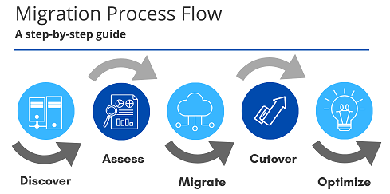

# Explore Azure database for MySQL

Azure Database for MySQL delivers:

* Built-in high availability with no additional cost.
* Predictable performance and inclusive, pay-as-you-go pricing.
* Scale as needed, within seconds.
* Ability to protect sensitive data at-rest and in-motion.
* Automatic backups.
* Enterprise-grade security and compliance.

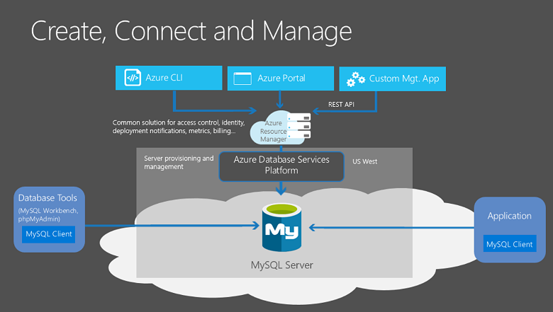



# Explore Azure Database for PostgreSQL

Moreover, Azure Database for PostgreSQL delivers the following benefits:

* Built-in high availability compared to on-premises resources. There's no additional configuration, replication, or cost required to make sure your applications are always available.
* Simple and flexible pricing. You have predictable performance based on a selected pricing tier choice that includes software patching, automatic backups, monitoring, and security.
* Scale up or down as needed, within seconds. You can scale compute or storage independently as needed, to make sure you adapt your service to match usage.
* Adjustable automatic backups and point-in-time-restore for up to 35 days.
* Enterprise-grade security and compliance to protect sensitive data at-rest and in-motion. This security covers data encryption on disk and SSL encryption between client and server communication.

Azure Database for PostgreSQL is available in two deployment options: **Single Server** and **Hyperscale (Citus)**.

**Single Server**

The Single Server deployment option delivers:

* Built-in high availability with no additional cost (99.99 percent SLA).
* Predictable performance and inclusive, pay-as-you-go pricing.
* Vertical scale as needed, within seconds.
* Monitoring and alerting to assess your server.
* Enterprise-grade security and compliance.
* Ability to protect sensitive data at-rest and in-motion.
* Automatic backups and point-in-time-restore for up to 35 days.
* All those capabilities require almost no administration, and all are provided at no additional cost. You can focus on rapid application development and accelerating your time to market, rather than having to manage virtual machines and infrastructure. You can continue to develop your application with the open-source tools and platform of your choice, without having to learn new skills.
* The Single Server deployment option offers three pricing tiers: Basic, General Purpose, and Memory Optimized. Each tier offers different resource capabilities to support your database workloads. You can build your first app on a small database for a few dollars a month, and then adjust the scale to meet the needs of your solution. Dynamic scalability enables your database to transparently respond to rapidly changing resource requirements. You only pay for the resources you need, and only when you need them.

**Hyperscale (Citus)**

* The Hyperscale (Citus) option horizontally scales queries across multiple machines by using sharding. Its query engine parallelizes incoming SQL queries across these servers for faster responses on large datasets. It serves applications that require greater scale and performance, generally workloads that are approaching, or already exceed, 100 GB of data.
* The Hyperscale (Citus) deployment option supports multi-tenant applications, real-time operational analytics, and high throughput transactional workloads. Applications built for PostgreSQL can run distributed queries on Hyperscale (Citus) with standard connection libraries and minimal changes

# Explore big data and analytics

Several years ago, Tailwind Traders rolled out a new GPS tracking system for all of its delivery vehicles. The new system provides real-time tracking data to your primary datacenter. Your CTO wants your team to look at several years of tracking data in order to determine trends

Open-source cluster technologies have been developed, over time, to try to deal with these large datasets. Microsoft Azure supports a broad range of technologies and services to provide big data and analytic solutions, including Azure Synapse Analytics, Azure HDInsight, Azure Databricks, and Azure Data Lake Analytics.

## Azure Synapse Analytics

[Azure Synapse Analytics](https://docs.microsoft.com/en-us/azure/sql-data-warehouse/) (formerly Azure SQL Data Warehouse) is a limitless analytics service that brings together enterprise data warehousing and big data analytics. You can query data on your terms by using either serverless or provisioned resources at scale. You have a unified experience to ingest, prepare, manage, and serve data for immediate BI and machine learning needs.

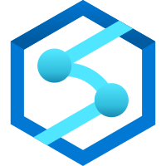

## Azure HDInsight



[Azure HDInsight](https://azure.microsoft.com/services/hdinsight/) is a fully managed, open-source analytics service for enterprises. It's a cloud service that makes it easier, faster, and more cost-effective to process massive amounts of data. You can run popular open-source frameworks and create cluster types such as [Apache Spark](https://docs.microsoft.com/en-us/azure/hdinsight/spark/apache-spark-overview), [Apache Hadoop](https://docs.microsoft.com/en-us/azure/hdinsight/hadoop/apache-hadoop-introduction), [Apache Kafka](https://docs.microsoft.com/en-us/azure/hdinsight/kafka/apache-kafka-introduction), [Apache HBase](https://docs.microsoft.com/en-us/azure/hdinsight/hbase/apache-hbase-overview), [Apache Storm](https://docs.microsoft.com/en-us/azure/hdinsight/storm/apache-storm-overview), and [Machine Learning Services](https://docs.microsoft.com/en-us/azure/hdinsight/r-server/r-server-overview). HDInsight also supports a broad range of scenarios such as extraction, transformation, and loading (ETL), data warehousing, machine learning, and IoT.

## Azure Databricks

[Azure Databricks](https://azure.microsoft.com/services/databricks/) helps you unlock insights from all your data and build artificial intelligence solutions. You can set up your Apache Spark environment in minutes, and then autoscale and collaborate on shared projects in an interactive workspace. Azure Databricks supports Python, Scala, R, Java, and SQL, as well as data science frameworks and libraries including TensorFlow, PyTorch, and scikit-learn.



## Azure Data Lake Analytics



[Azure Data Lake Analytics](https://azure.microsoft.com/services/data-lake-analytics/) is an on-demand analytics job service that simplifies big data. Instead of deploying, configuring, and tuning hardware, you write queries to transform your data and extract valuable insights. The analytics service can handle jobs of any scale instantly by setting the dial for how much power you need. You only pay for your job when it's running, making it more cost-effective.